Indicate membership investment level: □ Platinum ($2,500) □ Gold ($2000) □ Associate (500)

Company Name_____________________________________________________________

Contact ___________________________________________________________________

Mailing address_____________________________________________________________

City___________________________________ State______________ Zip _____________

E-mail address______________________________________________________________

Phone ( ) ________________________ Web site address ________________________________


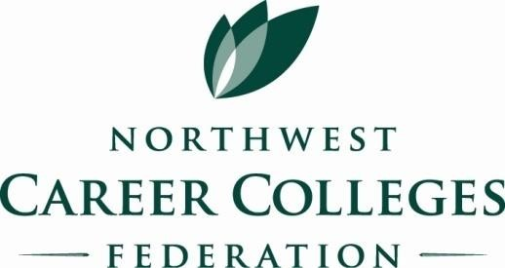
Please provide a description of the services offered by your company. This information will be used on the NWCCF web site to describe Industry Partners’ resources and services.

Making it easy for schools to find you…

Industry Partner

is a

good investment

I
ndustry Partner Application

Please check those areas of interest to you:
□ Display at the annual conference □ Speaker Opportunities
□ Notice of upcoming workshops or social events □ Sponsor a workshop presenter

Payment Information
If you would like to pay by ACH, please contact Deepti Taneja at deepti.taneja@career.org.
Checks: Checks payable to Alliance for Career Education in the States (ACES) should be mailed to Deepti Taneja at 1530 Wilson Boulevard, Suite 1050, Arlington, VA 22209.

